Excel Assignment - 8

*1. What do you mean by* *AutoComplete feature in Excel and what are the beneﬁts of using this feature?*

1. AutoComplete feature examines the contents of the active column in the data directly above and tries to anticipate what you are about to type.
2. AutoComplete is the automatic filling in of your text when you start typing and is switched on by default.
3. This will reduce the amount of text you have to enter by preventing you typing in repetitive words.
4. AutoComplete matches only exact cell entries, not individual words in a cell. This does not work when entering or editing formulas.

Benefits :-

1. AutoComplete helps you quickly insert functions and arguments while minimizing typing and syntax errors.
2. The AutoComplete menu shows you available options based on context, and you choose what you want to insert into your formula.
3. AutoComplete will only match on exact cell entries and not on individual words within a cell.

*2. Explain working with worksheets and working with cells.*

**Working with Worksheets :-** It is important that know how to effectively manage worksheets. By default, three worksheets appear in each new workbook.

1. Naming worksheets :-

When we open an Excel workbook, there are three sheets by default, and the default name on the tabs are Sheet1, Sheet2, and Sheet3. These are not very informative names. Excel 2007 allows us to create a meaningful name for each worksheet in a workbook so we can quickly locate information.

2. Inserting worksheets :-

We can change the default number of sheets that appears by clicking the Microsoft Office button and choosing Excel Options. We also have the ability to insert new worksheets if needed while we are working.

3. Deleting worksheets :-

Any worksheet can be deleted from a workbook, including those that have data in it. Remember, a workbook must contain at least one worksheet.

4. Grouping worksheets :-

Worksheets can be combined together into a group. Grouping worksheets allows you to apply identical formulas and/or formatting across all of the worksheets in the group. When you group worksheets, any changes made to one worksheet will be changed in any other worksheets in the group.

5. Freezing worksheet panes

The ability to freeze, or lock, specific rows or columns in your spreadsheet is a useful feature in Excel. It is called freezing panes. When you freeze panes, you select rows or columns that will remain visible all the time, even as you are scrolling. This is particularly useful when working with large spreadsheets.

**Working with cells :-**

It is important to know how to move information from one cell to another in Excel. Learning the various ways will save our time and make working with Excel easier. Certain methods are more appropriate, depending on how much information we need to move and where it will reside on the spreadsheet.

1. Cell content

Any data we enter in our Excel worksheet is stored in a cell. Each cell can hold various types of information, including string, numbers, formatting, formulas, and functions.

* 1. String (Text) : Cells can hold string values, unlike alphabets, numbers, and dates.
  2. Formatting properties : Cells also include formatting properties that improve the appearance of your cell content. For instance, percentages can be displayed as 0.55 or 55%. You can make the cell content in Bold, Italics, change its font color, font size, or change its background color.
  3. Formulas and functions : Cells can include predefined or customized formulas and functions that are helpful in calculations. For example, SUM(A2:A5) will add the number stored in each cell and give you the output.

1. copy and paste cell contents:

We can copy the cell content and paste in any other or multiple cells we want. This option will reduce our typing time and reduce repetative work.

2. cut and paste cell contents:

This function will help us to cut content from one cell and paste in other required cell.

3. Delete cell content :

This function will help us to delete unnecessary cell content.

4. Drag and drop cells :

Instead of copying and pasting the data, you can use the drag and drop option to move cell content from one cell to another.

*3. What is ﬁll handle in Excel and why do we use it?*

* The Fill Handle is an Excel feature that enables us to bypass the copy and paste of each value into cells and uses patterns instead of filling out the information.
* This tiny cross is a versatile tool in the Excel suite to perform data entry, transformation, and many other applications.
* It is an inbuilt feature of Excel and does not require any manual steps to enable it.

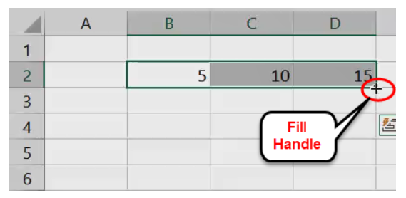

Uses of fill handle :-

1. We can use the fill handle to quickly copy and paste data into adjacent cells by dragging the fill handle to the cells we want to fill with the same data.
2. We can also use this feature to create a numbered list in excel by establishing a pattern for the first few cells and dragging the fill handle to the cell you want to be numbered.
3. We can enter Days Of The Month & Months of The Year Automatically.
4. We can use this feature to draw up various lists using patterns. We have to establish a pattern in the first few cells that need to be repeated and drag the fill handle until the cell we want the pattern to end.
5. We can use this feature also to copy a formula to adjacent cells by following a similar process to the one mentioned in our other examples. We have to create the excel formula in one cell and drag the fill handle till the required cell or cells as the case may be.
6. We can use it to separate values using different separators like commas, full stops, etc.

*4. Give some examples of using the ﬁll handle.*

1. We can use the fill handle to quickly copy and paste data into adjacent cells by dragging the fill handle to the cells we want to fill with the same data.

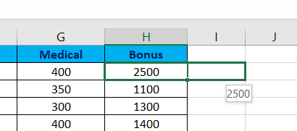

1. We can also use this feature to create a numbered list in excel by establishing a pattern for the first few cells and dragging the fill handle to the cell you want to be numbered.

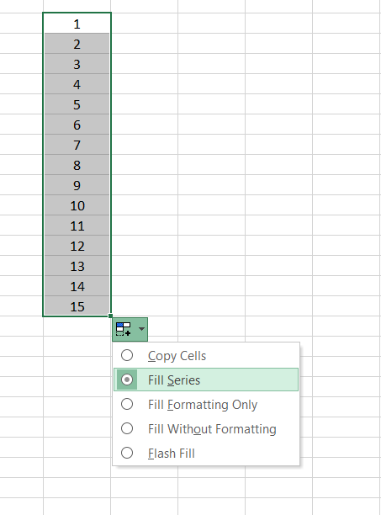

*5. Describe ﬂash ﬁll and what the diﬀerent ways to access the ﬂash ﬁll are.*

* Flash Fill automatically fills our data when it senses a pattern.
* For example, you can use Flash Fill to separate first and last names from a single column, or combine first and last names from two different columns.
* Excel Flash Fill is a special feature introduced by Microsoft that examines the data entered by the user and if it involves any kind of pattern it automatically fills the remaining information in a single click."
* Flash Fill quickly copes with several different tasks that otherwise need complicated formulas or even lengthy VBA code, unlike splitting and merging strings, sorting the data and correcting deviations, formatting the content or the numbers, turning dates figure to the required format, and a lot more.
* Every time you apply Flash Fill to Excel worksheet at the backend to accomplish that, it merges millions of multiple small programs, sorts those program snippets utilizing machine-learning algorithms, and ascertains the flawless job. To our surprise, all these activities are done in milliseconds. Therefore delivering the output almost immediately!

diﬀerent ways to access the ﬂash ﬁll are :

* Flash Fill shortcut key : One of the reasons why Excel is popular among its users is because of its shortcut keys. Excel provides shortcut key keys for almost every operation. Those who quickly want to access Flash Fill without using a mouse can run it directly from the keyboard using the shortcut keys: Ctrl + E.

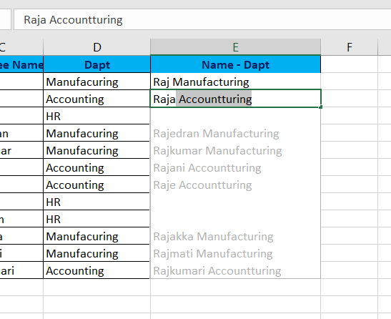

* If Flash Fill doesn't generate the preview, it might not be turned on. We can go to **Data** > **Flash Fill** to run it manually.
* To turn Flash Fill on, go to **Tools** > **Options** > **Advanced** >**Editing Options** > check the **Automatically Flash Fill** box.

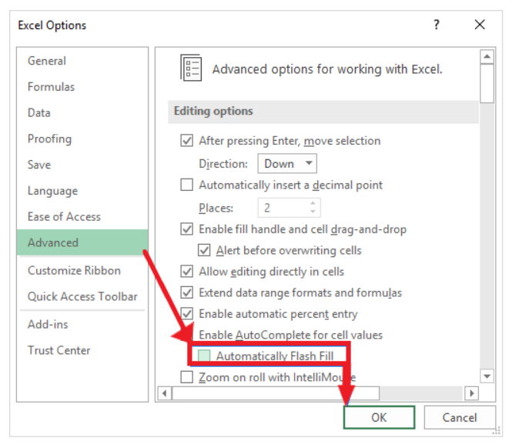

* The **Flash Fill Options** button is displayed next to the auto-filled cells. Clicking on the options menu button will open the following window:

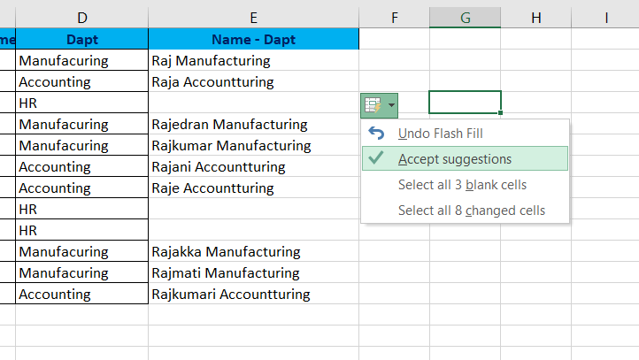

*6. Extract ﬁrst name and last name from the mail id and then from the address column, extract the city, state, and pin code using the ﬂash ﬁll.*

*Given below is an example of the columns you have to create. Paste the screenshot of what you have created using the ﬂash ﬁll command.*

*Example: Mail Id, Address, First name, Last name, State, City, Pincode.*

*1.* In below table , First name is flashfilled.

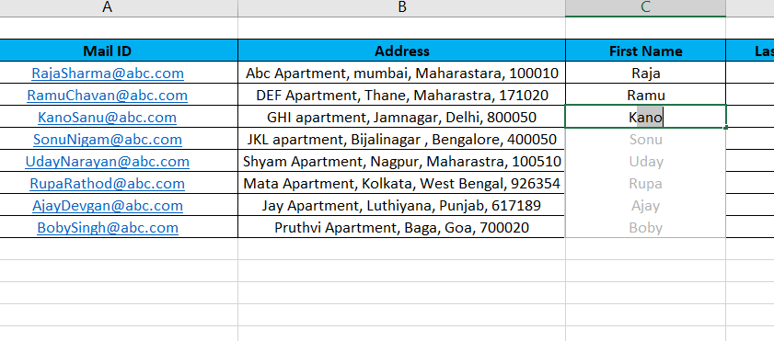

*2.* In below table , Last name is flashfilled by slecting fill option and in that flash Fill option.

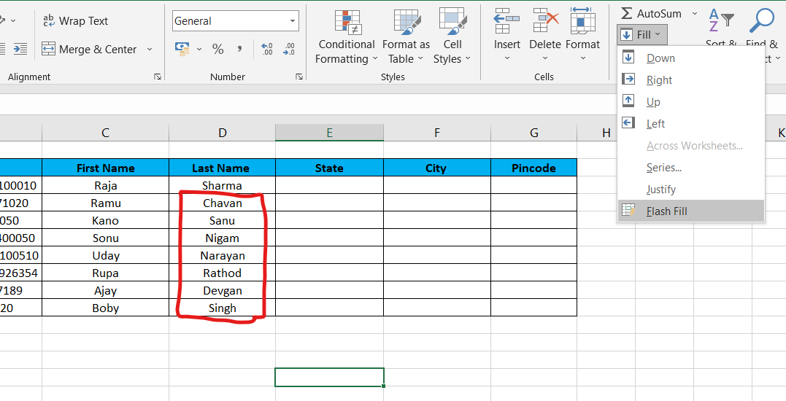

3. In below table , State is flashfilled by slecting fill option and in that flash Fill option.

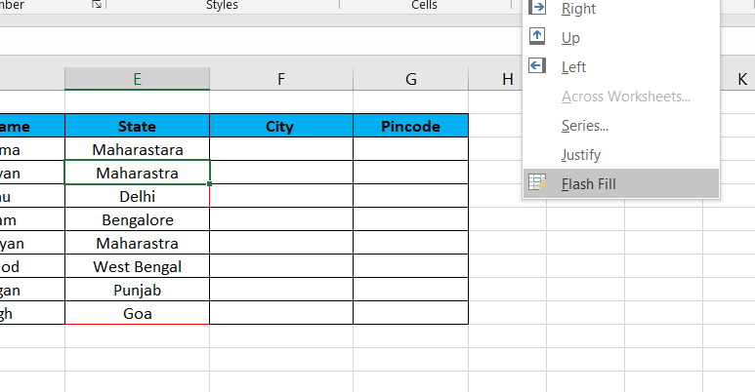

4. Similarly In below table, City and pin code is flashfilled by selecting fill option and in that flash Fill option.

